Packet Tracer – Configuring Basic OSPFv3 in a Single Area

1. Topology

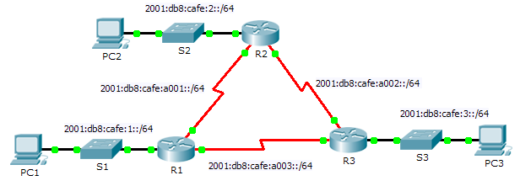

1. Addressing Table

|  |  |  |  |
| --- | --- | --- | --- |
| Device | Interface | IPv6 Address/Prefix | Default Gateway |
| R1 | F0/0 | 2001:db8:cafe:1::1/64 | N/A |
| S0/0/0 | 2001:db8:cafe:a001::1/64 | N/A |
| S0/0/1 | 2001:db8:cafe:a003::1/64 | N/A |
| R2 | F0/0 | 2001:db8:cafe:2::1/64 | N/A |
| S0/0/0 | 2001:db8:cafe:a001::2/64 | N/A |
| S0/0/1 | 2001:db8:cafe:a002::1/64 | N/A |
| R3 | F0/0 | 2001:db8:cafe:3::1/64 | N/A |
| S0/0/0 | 2001:db8:cafe:a003::264 | N/A |
| S0/0/1 | 2001:db8:cafe:a002::2/64 | N/A |
| PC1 | NIC | 2001:db8:cafe:1::10/64 | fe80::1 |
| PC2 | NIC | 2001:db8:cafe:2::10/64 | fe80::2 |
| PC3 | NIC | 2001:db8:cafe:3::10/64 | fe80::3 |

1. Objectives

Part 1: Configure OSPFv3 Routing

Part 2: Verify Connectivity

1. Background

In this activity, the IPv6 addressing is already configured. You are responsible for configuring the three router topology with basic single area OSPFv3 and then verifying connectivity between end devices.

1. Configure OSPFv3 Routing
   1. Configure OSPFv3 on R1, R2 and R3.

Use the following requirements to configure OSPF routing on all three routers:

* 1. Enable IPv6 routing
  2. Process ID 10
  3. Router ID for each router: R1 = 1.1.1.1; R2 = 2.2.2.2; R3 = 3.3.3.3
  4. Enable OSPFv3 on each interface

**Note:** Packet Trace version 6.0.1 does not support the **auto-cost reference-bandwidth** command, so you will not be adjust bandwidth costs in this activity.

* 1. Verify OSPF routing is operational.

Verify each router has established adjacency with the other two routers. Verify the routing table has a route to every network in the topology.

1. Verify Connectivity

Each PC should be able to ping the other two PCs. If not, check your configurations.

**Note:** This activity is graded using only connectivity tests. The instructions window will not show your score. To see your score, click **Check Results** > **Assessment Items**. To see the results of a specific connectivity test, click **Check Results** > **Connectivity Tests**.